

CARDS
-
OBJECTIVE CARDS



OBJECTIVE CARD

OBJECTIVE CARD

SUMMARY OBJECTIVE CARD

.
OBJECTIVE CARD

SUMMARY OBJECTIVE CARD

OBJECTIVE CARD

SUMMARY OBJECTIVE CARD

OBJECTIVE CARD

OBJECTIVE CARD

OBJECTIVE CARD


OBJECTIVE CARD

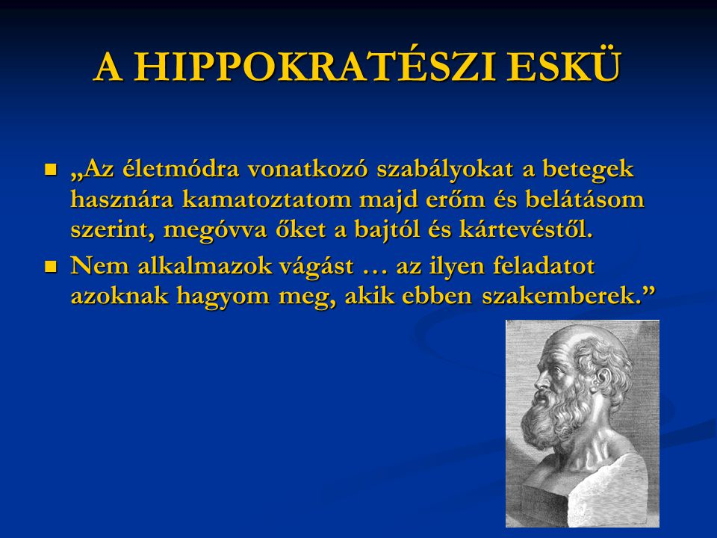
OBJECTIVE CARD



To make enough money.
To be loved.
To teach something that makes the other more.
Living life to the fullest.
Survive another day.
To perfect a skill.
To travel, to see the world.
To spread good thoughts.
To retire once (retirement).
OBJECTIVE CARD



OBJECTIVE CARD



OBJECTIVE CARD


OBJECTIVE CARD



OBJECTIVE CARD


OBJECTIVE CARD



OBJECTIVE CARD



OBJECTIVE CARD

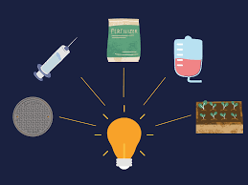

OBJECTIVE CARD

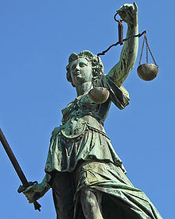

To acquire property ownership.
Eat well.
To live a virtuous life.
Start a family.
To serve the common good.
To play.
To uncover the truth.
To discover some scientific knowledge.
To get land.
OBJECTIVE CARD



OBJECTIVE CARD



OBJECTIVE CARD

.
OBJECTIVE CARD



OBJECTIVE CARD



OBJECTIVE CARD



OBJECTIVE CARD



OBJECTIVE CARD



OBJECTIVE CARD


Keeping and raising animals.
To get a title.
Living according to expectations (family, close environment).
​
To live up to expectations (social).
Immerse onerself in the 'flow'.
​
Send feedback
Side panels
More details
To live an honorable life.
To achieve financial security in the long term.
To become a champion.
To die in glory.
OBJECTIVE CARD



OBJECTIVE CARD

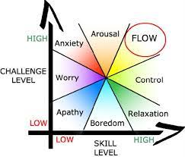

OBJECTIVE CARD


OBJECTIVE CARD



OBJECTIVE CARD



OBJECTIVE CARD

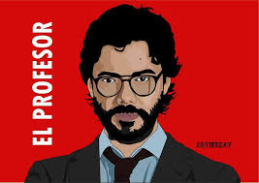

OBJECTIVE CARD



OBJECTIVE CARD

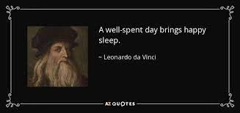

OBJECTIVE CARD



To evangelize.
To develop the country.
Eliminate a problem forever.
To advance in the ranks.
Read all the books I want.
To reach spaces, where no one has gone before.
Partying a lot.
To die happy.
To do the right thing.
OBJECTIVE CARD



OBJECTIVE CARD



OBJECTIVE CARD

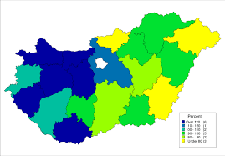
OBJECTIVE CARD

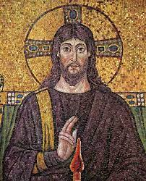

OBJECTIVE CARD



OBJECTIVE CARD



OBJECTIVE CARD



OBJECTIVE CARD



OBJECTIVE CARD

Breaking a bad habit.
To become capable of self-defense.
To be strong.
Being fit.
To become a professional in a sport.
Try all the sports I wanted.
To correct a mistake of mine.
To correct my mistakes.
Making amends for the harm I have caused to others.
OBJECTIVE CARD



OBJECTIVE CARD



OBJECTIVE CARD



OBJECTIVE CARD



OBJECTIVE CARD

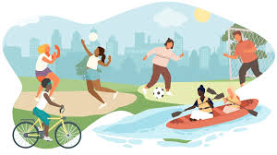

OBJECTIVE CARD

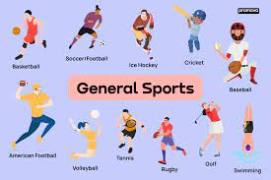

OBJECTIVE CARD

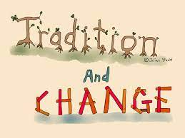

OBJECTIVE CARD

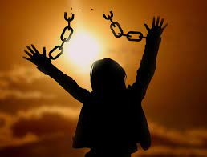

OBJECTIVE CARD



To become famous.
To heal an illness/injury.
Learn as many levels of meditation as possible.
To become nothing.
To reach nirvana.
To live forever.
To withdraw from society.
To be released from an obligation.
Choose the traditions to follow.
OBJECTIVE CARD



OBJECTIVE CARD



OBJECTIVE CARD

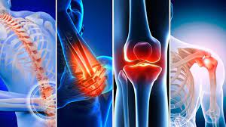
OBJECTIVE CARD

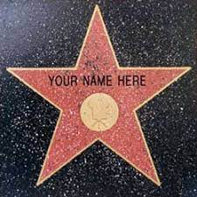

OBJECTIVE CARD

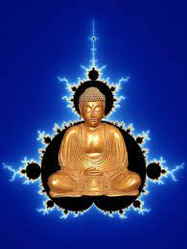

OBJECTIVE CARD



OBJECTIVE CARD



OBJECTIVE CARD



OBJECTIVE CARD



To find one's own moral rules.
Conquer a woman/man.
Finding work that you enjoy doing.
To be more beautiful.
To be faster.
To live a quiet life.
To keep the law.
Convince someone to do the 'dirty work'.
To forgive.
OBJECTIVE CARD



OBJECTIVE CARD

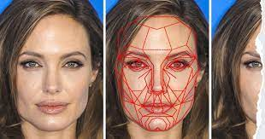

OBJECTIVE CARD


OBJECTIVE CARD

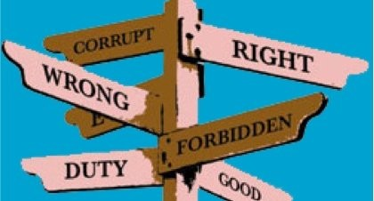

OBJECTIVE CARD


OBJECTIVE CARD

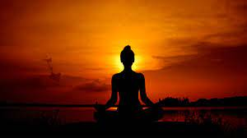

OBJECTIVE CARD

OBJECTIVE CARD

OBJECTIVE CARD

OBJECTIVE CARD

OBJECTIVE CARD

OBJECTIVE CARD

OBJECTIVE CARD

OBJECTIVE CARD

OBJECTIVE CARD

The project is funded by the European Solidarity Corps.

The contents of this post reflect the views only of the author, and the European Commission cannot be held responsible for any use which may be made of the information contained therein.

CHOICE ON THE FIELD***© 2021-2023and all original, own work,
product and it's part which can be seen here, made by
the ’Személyre szabott pályaválasztási tanácsadás-sorozat 2021 - 2022, 2021-1-HU01-ESC30-SOL-000036891’ project,which is not attributed / attributable to
others is licensed under CC BY-NC 4.0. To view a copyof this license, visit:
http://creativecommons.org/licenses/by-nc/4.0/

