

CARDS
-
PROFESSIONS



CREATIVE ART

WORKING HOURS

JOB
Creative art is an occupational field where people express themselves and create something new with the help of different art forms, such as paintings, sculptures, graphics.
BENEFITS
POSITION

MUNKAIDŐ

LIBERAL ARTS

WORKING HOURS
JOB
In the Humanities occupational field, people study human culture, language, history, and literature to understand people's past and present and to better understand themselves and the world.
BENEFITS
POSITION

An occupational field where mineral raw materials are mined and processed to create various metals and other materials used in cars, buildings…
POSITIBN
JOB

BENEFITS
WORKING HOURS
MINING AND METALLURGY


HEALTHCARE

WORKING HOURS

JOB
The field of health care deals with the preservation and restoration of health, for example, doctors cure patients, nurses help them, and researchers develop new cures and treatments.

BENEFITS
POSITION

MUNKAIDŐ

ELECTRONICS - ELECTRICAL TECHNOLOGY

WORKING HOURS
JOB
Electrical technology deals with electrical energy, while electronics deals with the production, transmission and use of information and control signals.
BENEFITS
POSITION

A prison director, prison warden, prison guard, coach, chiropractor, dealer (casino), church founder, stone carver, mushroom picker, bell maker, bow maker...

.

POSITION
JOB

BENEFITS
WORKING HOURS
OTHER, DIFFICULT -/ in several ways CATEGORIZable PROFESSIONS
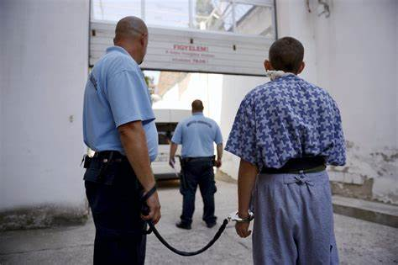

FOOD INDUSTRY
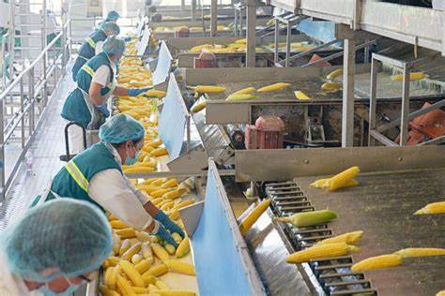
WORKING HOURS

JOB
In the area, they are engaged in the production and processing of food, for example by processing agricultural crops into food, drinks or sweets, baked goods, cheese or meat preparations.

BENEFITS
POSITION

MUNKAIDŐ

BUILDING ENGINEERING

WORKING HOURS
JOB
In general, building engineering deals with pipe networks within buildings, their fittings and related equipment, heating technology; with water supply and sewerage; gas supply, air conditioning.
BENEFITS
POSITION

They deal with the design and construction of buildings, such as building, renovating or repairing houses, offices, bridges or roads.
POSITION
JOB

BENEFITS
WORKING HOURS
BUILDING INDUSTRY


WOOD AND FURNITURE INDUSTRY
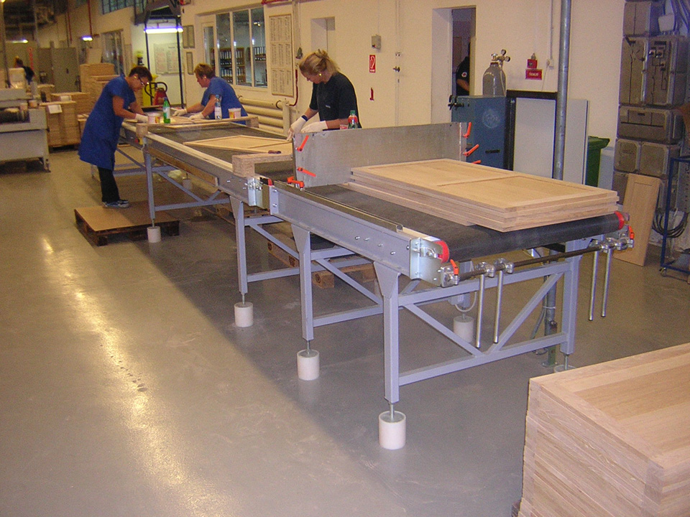
WORKING HOURS

JOB
In the wood industry, they work with wood, and use it to make furniture and other wood products, for example: doors, windows, sculptures.
BENEFITS
POSITION

MUNKAIDŐ
Professions in the group are e.g. casting director, dramaturg, DIT digital recording technician, stunt double, wedding planner, lighting technician, screenwriter, sound engineer, sound technician, production manager, sound technician, host/hostess…

ECONOMY AND MANAGEMENT

WORKING HOURS
JOB
Professions: economist majoring in management and economics, economic and finance-mathematical analyst, economist (majoring in applied economics), technical manager, economist majoring in international management, financial and accounting expert, financial and accounting clerk, business administration clerk.

BENEFITS
POSITION

POSITION
JOB

BENEFITS
WORKING HOURS
FILM, THEATER, MEDIA, EVENTS
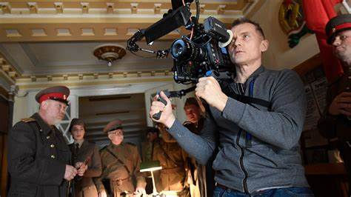

MECHANICAL ENGINEERING

WORKING HOURS

JOB
They are engaged in the design, manufacture and maintenance of machines.
BENEFITS
POSITION

MUNKAIDŐ
It deals with the management and transmission of information, databases, the Internet, as well as data protection, cyber security, and the development and maintenance of communication tools.

LAW


WORKING HOURS
JOB
Law deals with the laws, rules, regulations, and court procedures that govern people's rights and duties. Lawyers are responsible for the legal representation of clients and advice. Other professions: judicial organizer, labor and social security administration specialist, notary public.
BENEFITS
POSITION

POSITION
JOB

BENEFITS
WORKING HOURS
IT AND TELECOMMUNICATION


COMMERCE

WORKING HOURS

JOB
It deals with the sale of goods, using different channels, for example through store sales / online trade.
BENEFITS
POSITION

MUNKAIDŐ

ENVIRONMENTAL PROTECTION AND WATER AFFAIRS

WORKING HOURS
JOB
Specialists perform tasks such as the protection of the natural environment and water management. They help protect the environment and wildlife, and ensure the sustainable utilization of water resources.
BENEFITS
POSITION

It is characterized by handicraft products, textiles, clothing products, leather, leather products, footwear production, wood processing, woven goods, paper, paper product production, reproduction activities.
​

POSITION
JOB

BENEFITS
WORKING HOURS
HANDICRAFTS AND LIGHT INDUSTRY


TRANSPORTATION AND DELIVERY

WORKING HOURS

JOB
In the area, they deal with work related to transport and freight. Jobs for example:
traffic engineer, driver service employee, flight attendant,
truck driver.
BENEFITS
POSITION

MUNKAIDŐ

ARTS

WORKING HOURS
JOB
Professions for example: goldsmith, artist, clown, bronze worker and statue caster, circus master, decorative painter, church musician, entertainer, silversmith, jazz musician, classical musician, choreographer.

BENEFITS
POSITION

Agriculture includes the care of animals, food production, and crop cultivation.
Forest management protects and cares for the wildlife of the forests, monitors the forest's tree population and flora, and carries out forest management works in accordance with nature conservation and economic aspects.
POSITION
JOB

BENEFITS
WORKING HOURS
AGRICULTURE - FORESTRY


EDUCATION, PEDAGOGY

WORKING HOURS

JOB
A professional field concerned with understanding and improving the process of teaching and learning, where teachers and other educational professionals help students expand their knowledge and develop their skills.
BENEFITS
PSOTITION

MUNKAIDŐ

SPORT


WORKING HOUR
JOB
Professions, for example: coach, fitness-wellness instructor, martial artist, sports and recreation organizer, sports trainer-sports organizer, swimming master, bodybuilder.
BENEFITS
POSITION

The area includes the military, police, fire brigade, disaster protection and other state bodies, which serve to maintain public order and security, as well as to protect the state.

POSITIN
JOB

BENEFITS
WORKING HOURS
POLICE, HOMELAND DEFENSE AND PUBLIC SERVICE


BEAUTY INDUSTRY

WORKING HOURS

JOB
Professions, for example: hairdresser, hair extension technician, hand and foot care technician, beautician (e.g. make-up tattoo artist), make-up artist, eyelash artist.
BENEFITS
POSITION

MUNKAIDŐ

SOCIAL SCIENCES

WORKING HOURS
JOB
They study social phenomena, processes, customs, norms and values in order to better understand society and its functioning, the phenomena and their historical, economic and political connections.
BENEFITS
POSITION

Deals with helping social groups such as the elderly, the disabled, the homeless, the young, the poor, and those with learning difficulties.

POSITION
JOB

BENEFITS
WORKING HOURS
SOCIAL SECTOR
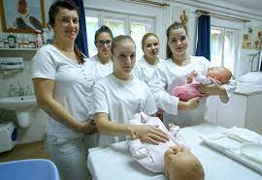

NATURAL SCIENCES

WORKING HOURS

JOB
Professions, for example: biologist, bioengineer, physicist, geoscience researcher, geoscience engineer, geographer, environmental researcher, mathematician, meteorologist.
BENEFITS
POSITION

MUNKAIDŐ
The chemical industry develops and manufactures chemical substances.
Its products are indispensable in most modern industries (medicines, plant protection agents, fertilizers, cosmetics, cleaning and washing agents...).
It deals partly with the transformation of materials found in nature, partly with the production of new (artificial) materials.

SERVICE INDUSTRY AND TOURISM

WORKING HOURS
JOB
Professions, for example: barback, barista, confectioner / confectioner technician, mixer, innkeeper, waiter, bartender.
BENEFITS
POSITION

POSITION
JOB

BENEFITS
WORKING HOURS
CHEMICAL INDUSTRY


+ BUSINESS


WORKING HOURS

Businesses can be founded in almost any field related to the above professions.
BENEFITS

MUNKAIDŐ

WORKING HOURS
JOB

BENEFITS
POSITION

POSITION
JOB

BENEFITS
WORKING HOURS

The project is funded by the European Solidarity Corps.

The contents of this post reflect the views only of the author, and the European Commission cannot be held responsible for any use which may be made of the information contained therein.

CHOICE ON THE FIELD***© 2021-2023and all original, own work,
product and it's part which can be seen here, made by
the ’Személyre szabott pályaválasztási tanácsadás-sorozat 2021 - 2022, 2021-1-HU01-ESC30-SOL-000036891’ project,which is not attributed / attributable to
others is licensed under CC BY-NC 4.0. To view a copyof this license, visit:
http://creativecommons.org/licenses/by-nc/4.0/

